**What makes the X VR Headset different? (*Abstract*)**

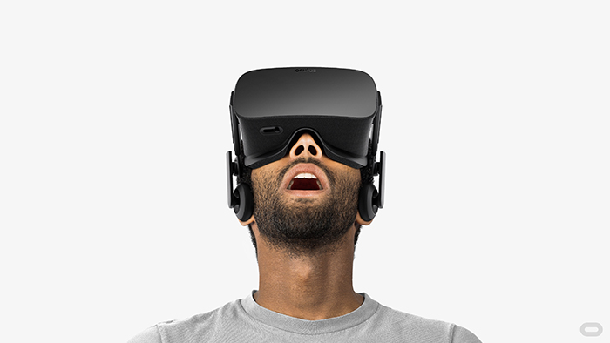The X VR Headset isn’t just a virtual reality device which offers nothing but the display of a 3D world. This new product has been launched with an innovative technique: the Optogenetics technique. Signals can be transmitted to the brain and cause specific sensory inputs. This provides a very accurate visual recreation of the game and comes with a physical sensation option. In addition to that, the device has both, *head motion* and *eye tracking* sensors.

**What is the X VR Headset? (Sensation VR Headset??)**

**Definition**

X Headset is a virtual reality device that uses different technologies in order to allow users to dive into a whole new world. The headset, which is a head mounted display, recreates a 3D virtual environment in front of the user’s eyes. Such headsets can be used in a vast variety of applications, but are mostly used with games. They come with a XXXXX software…….

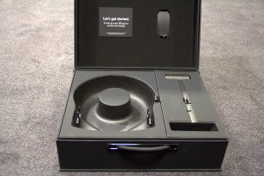**The X VR Headset**

The product includes the lenses, display, eye and head motion tracking technology, audio as well as the Neuro-sensors. The package comes with a convenient suitcase you can always use to put your headsets in. There is also space for other devices as well.

The suitcase

The X VR Headset perfectly sits on every user’s head, is very light and weighs only 318 grams. In addition, the weight is evenly distributed as it sits on the head. It is designed so that the user does not feel any pressure on the nose and therefore is very comfortable for everyone. The tapes, which keep the device in place, are made of a very elastic and adjustable material that makes the headset suitable for individuals of every age and size. The earphones are also intended to fit everyone’s ears without causing any pressure. They are detachable for anyone who chooses to use other models instead. The headset can be connected to different devices via Bluetooth or Wireless. This groundbreaking industrial design offers its users the full experience of the XXX Game.

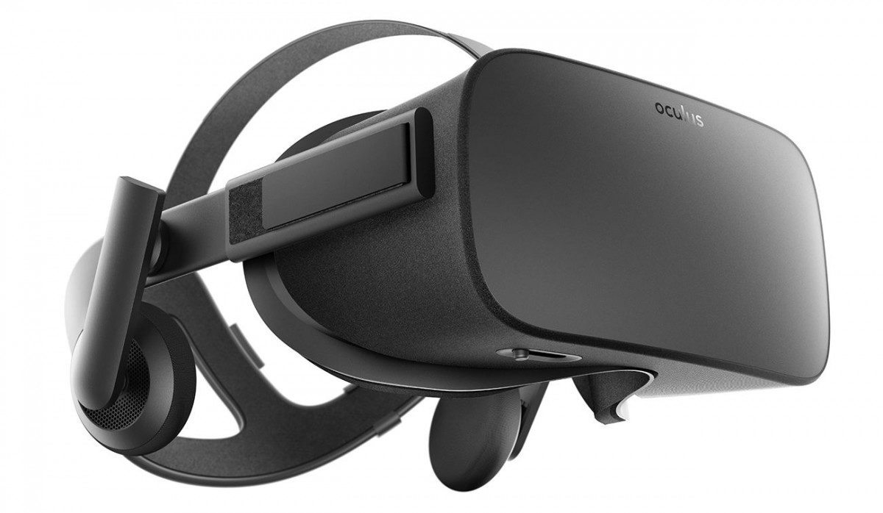

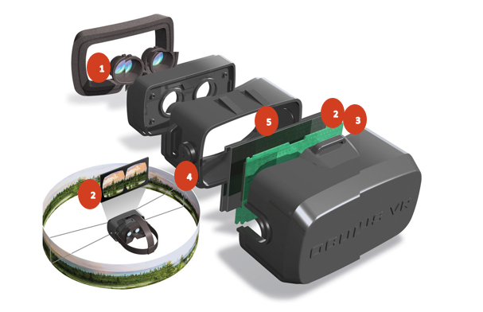**The X VR Headset in Detail**

1. **Lenses**
2. **Display**
3. **Eye tracking technology, head motion tracking technology**
4. **Audio**
5. **Neuro-stimulators**
6. **Microphone [not shown]**
7. **Lenses**

The lenses are made up of concentric prisms of uniform thickness. They provide crystal clear, stable vision. They were made to establish a focal point, so that the user can perceive the depth of the image, which essentially means that the player can stare beyond the virtual environment of the XXX game.

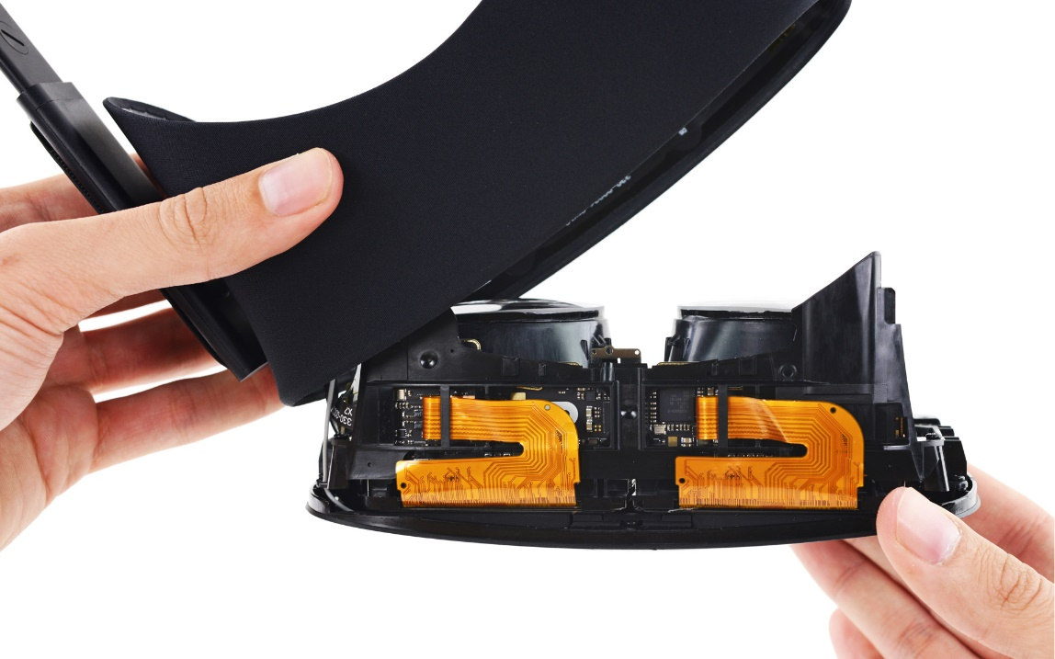

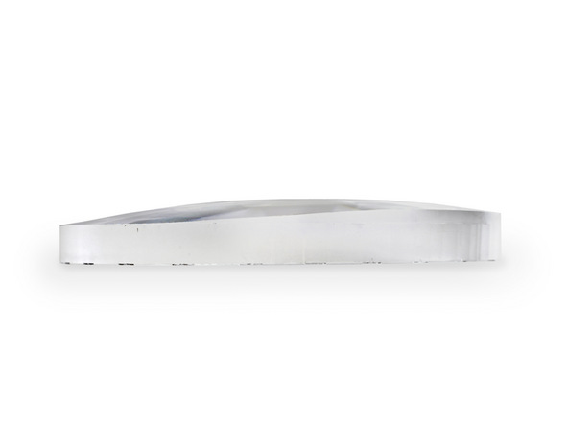

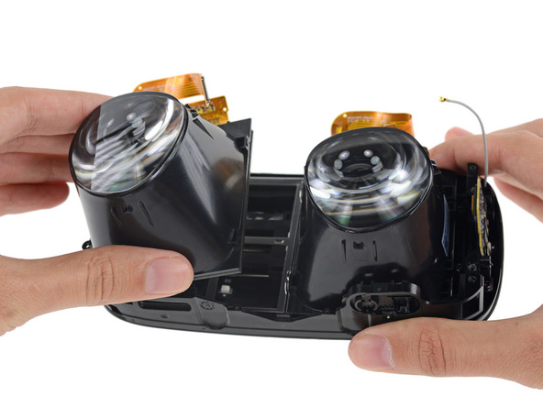

1. **Display**

The X VR Headset features 1080*1200 pixels for each eye with 90 Hz dual split screens. The screen stands a few inches from a user’s eyes and projects a *stereoscopic image*. When the 2D images are viewed in close proximity, users will be able feel like they stand in a virtual world.

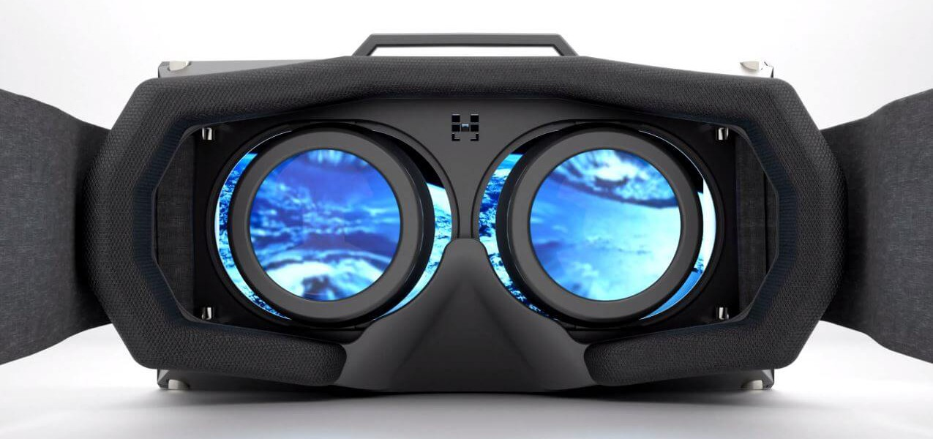Warning: Looking at the display screen for more than three hours without interruption can cause a nausea feeling in certain sensitive individuals. It is advised to use the device for a 2 – 2,5 hours long period.

1. **The tracking technology** (eye and head motion tracking)

X is built with a dozen sensor inputs. The device is able to track a player’s head due to a *gyroscope*, *accelerometer* and a compass. This makes the adaption of the images of a virtual world to the position of the head possible. A camera has been also included to enhance accuracy. The headset collects eye data by simply using a head-mounted eye tracker. The eye tracker includes two common components: a light source and a camera (mentioned above). The camera tracks the reflection of the light source along with visible ocular features such as the pupil. This data is used to extrapolate the rotation of the eye and ultimately the direction of gaze.

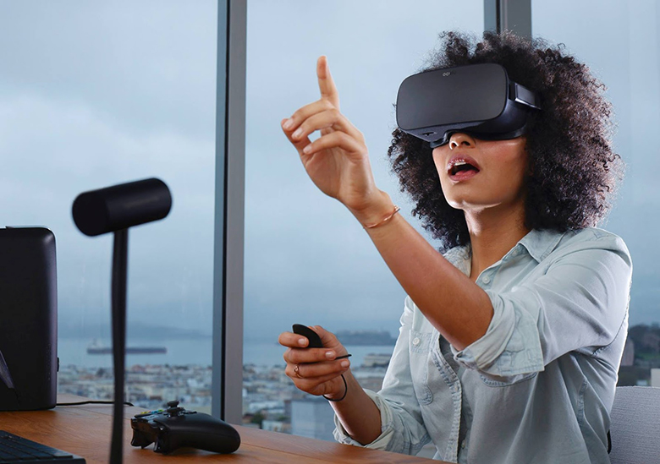

1. **Audio**

X is equipped with Head Transfer Function Technology, which combined with the head tracking sensors offers a 3D audio ‘spatialisation’. This technology achieves this by using the data that represent changes which would happen to a sound coming from a certain direction. This makes the game world seem like reality.

The small earphones are however detachable, which means that users could use other earphones if they would like.

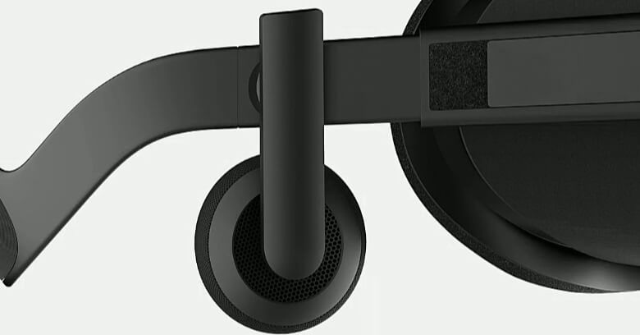

1. **Neuro-stimulators**

There are two stimulators, each located on every side of the headset touching the temples when the headset has been put on. This technique is based on *optogenetics*. Both devices send precisely timed pulses of light aimed at targeted regions of neurons. Such pulses cause the player to actually feel the objects they want to touch during the game. This could make the user lose himself in the virtual world. That’s why these sensors can be completely turned off. There as an on/off small red button on the left side of the headset.

Warning: Children under the age of 12 and psychologically unstable users should not use this option, as it can easily affect their sensations and feelings or even shock them.

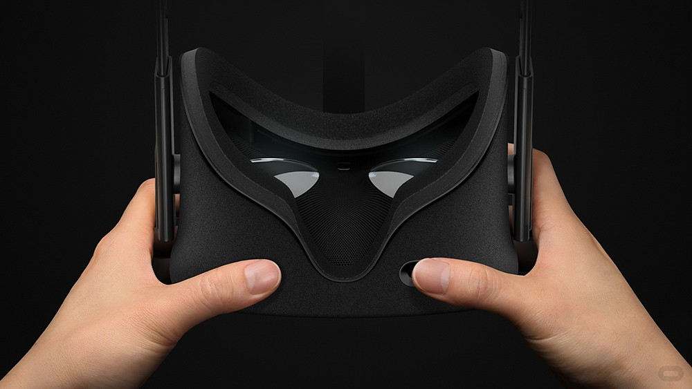

1. **Microphone**

The microphone is enclosed within the device in part of the structure close to the mouth. It is located on both LED Arrays. It offers features like: in-game chat, voice commands or ambient noise volume adjustment.

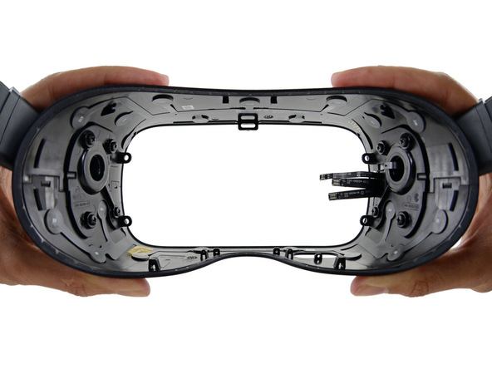

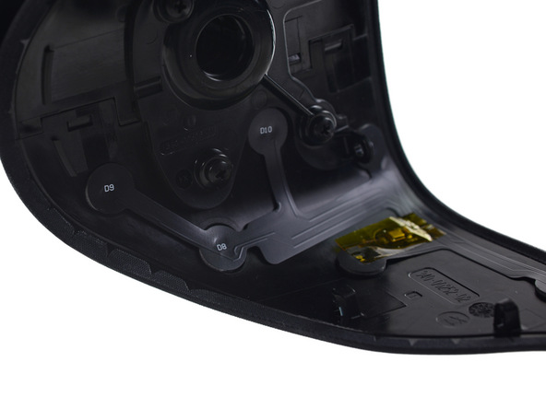

**Sources**

<http://www.vrnerds.de/oculus-rift-review-test/> - OCULUS RIFT

<http://computer.howstuffworks.com/brain-computer-interface.htm> - BCI brain-computer

<http://www.mediamarkt.de/de/product/_samsung-gear-vr-lite-2076364.html#technische-daten> - technical information

<https://www3.oculus.com/en-us/rift/> - Oculus Rift used for images

**Glossary**

* Eye tracking sensors –is a device for measuring eye positions and eye movement
* Head tracking - the picture displayed in front of the user shifts as one looks up, down and side to side or angles his head
* Stereoscopic image – 2 warped images on each half of the screen
* Pixel resolution - the capability of the sensor to observe or measure the smallest object clearly with distinct boundaries
* Neuron – electrically excitable cell that processes and transmits information through electrical and chemical signals
* Gyroscope – a device that senses angular velocity
* Accelerometer – a device used to measure the acceleration of a moving or vibrating body
* Optogenetics – is a biological technique which involves the use of light to control cells in living tissue, typically neurons
* LED-Arrays - assemblies of LED packages or dies that can be built using several methods. Each method hinges on the manner and extent to which the chips themselves are packaged by the LED semiconductor manufacturer

|  |  |
| --- | --- |
|  |  |